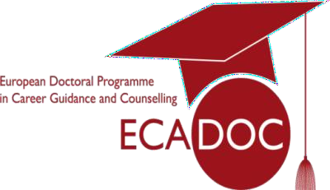**COCAG COST Training Event:**

**ECADOC Summer School**

**DSW University of Lower Silesia, 2nd to 6th June 2025**

**APPLICATION FORM**

# Personal details

|  |  |
| --- | --- |
| Family name(s): |  |
| Given name(s): |  |
| Birth date: |  |
| Nationality/nationalities: |  |
| Gender: |  |
| Current address/ residence: |  |
| Email address: |  |
| Start date of PhD: |  |

1. **Student Status**

I am currently registered as a PhD student/doctoral researcher at (please name the university and faculty)………………………………………………………………………………………

…………………… in (please name the country)……………………………………………….

1. **PhD Background**

|  |  |
| --- | --- |
| o I am a full-time researcher | o I am a part-time PhD researcher |
| o I am in a PhD programme with taught courses. | o I have a scholarship which finances a large part of my PhD research |
| o I am an individual PhD researcher not following taught courses at this level | o I finance my own PhD studies |
| o I will obtain my PhD on the strength of a required number of publications | o I have participated in other doctoral summer or winter schools. If so mention which: |
| o I am doing a PhD as an employee of a higher education institution |

1. **Please indicate your PhD research progress until now (tick several categories if applicable)**

|  |
| --- |
| o I am in the process of defining the goals and the approach of my PhD research |
| o My research plan is complete and I have begun my investigation |
| o I have already completed more than half of my analysis |
| o I have already published first articles on the theme of my research |
| o I am close to finalizing my PhD thesis (less than 1 year until final examination) |

1. **Please give your reasons and motivations for applying to the Summer School (maximum 200 words)**

**Please continue to the next page to sign your application**

**Attachments (please attach the following documents to this application form)**

1. Proof of PhD enrolment: Either a certificate of enrolment or written statement by your supervisor as proof that you are currently beginning, undertaking or completing a PhD.
2. A 1 page description of your doctoral research project, which illustrates the relevance to the career counselling and guidance field.
3. Your CV

All documentation (except for certificates) must be in English. This application form and the supporting documents must be submitted as one file to ecadoc@dsw.edu.pl no later than **31st January 2025**.

# Signature

I, the undersigned, realise that my application can only be processed, if I have:

1. Filled out this application form
2. Attached all the necessary documents
3. Submitted by application by the deadline of 31st January 2025

I hereby confirm that I have filled out this application form truthfully. I understand that only a limited number of participants can be accepted.

If I am accepted, but unable to attend, I will inform the organisers immediately, so that potential participants on the waiting list can be offered the opportunity to attend.

I agree to the ECADOC Summer School organisers processing the submitted information for the purpose of managing the event.

……………………………......

Date/Location

……………………………………..

Signature